Task 1:
#include<iostream>
using namespace std;
class node{
public:
int data;
int key;
node* next;
node* prev;
node(int k, int val){
this->data = val;
this->key = k;
next =NULL;
prev=NULL;
}
};
class LinkedList{
public:
node* head;
node* tail;
LinkedList(){
head =NULL;
tail-=NULL;
}
// Inserting at the head
void insertAtHead(int k,int val){
node* newnode = new node(k,val);
if(head==NULL){
head=newnode;
tail=newnode;
return;
}
newnode->next = head;
head->prev = newnode;
head= newnode;
return;
}
//inserting node at the tail
void insertAtEnd(int k,int val){
node* newnode =new node(k,val);
if(head==NULL){
head=newnode;
tail=newnode;
return;
}
tail->next = newnode;
newnode->prev=tail;
tail=newnode;
return;
}
//inserting the node after the position
void insertAtPos(int pos,int k,int val){
node* temp=head;
int count=1;
while(count<(pos-1)){
temp=temp->next;
count++;
}
node* newnode = new node(k,val);
newnode->next=temp->next;
temp->next = newnode;
newnode->prev = temp;
temp->next->prev=newnode;
}
//Delete the node via key
void deleteViaKey(int k){
node* temp=head;
while(temp->key!=k){
temp= temp->next;
}
// now we are at the pos of deleting
temp->prev->next = temp->next;
temp->next->prev = temp->prev;
}
// Display fun
void display(){
node* temp=head;
while(temp!=NULL){
cout<<temp->data<<"->";
temp=temp->next;
}
cout<<"Null";
}
};
int main(){
LinkedList newlist;
newlist.insertAtHead(1,3);
newlist.insertAtHead(2,66);
newlist.display();
cout<<endl<<"Inserting(76 ,36 78) at the end of the list"<<endl;
newlist.insertAtEnd(3,76);
newlist.insertAtEnd(4,36);
newlist.insertAtEnd(5,78);
newlist.display();
cout<<endl;
cout<<"Inserting the value(100) at the 3rd position"<<endl;
newlist.insertAtPos(3,6,100);
newlist.display();
cout<<endl<<"Deleting the value at key 4 which is 36 "<<endl;
newlist.deleteViaKey(4);
newlist.display();
}
OUTPUT:
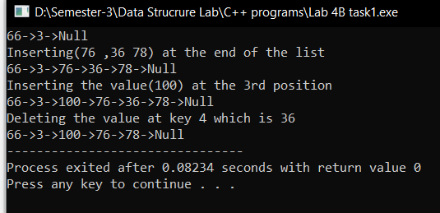

Task 2
#include<iostream>
using namespace std;
class node{
public:
int data;
node* next;
node* prev;
node(int val){
this->data = val;
next = NULL;
prev=NULL;
}
};
class cirLinkedList{
public:
node* head;
node* tail;
cirLinkedList(){
head = NULL;
tail = NULL;
}
// Adding the node at the end
void insertAtEnd(int val){
node* newnode = new node(val);
if(head==NULL){
newnode->next= newnode;
newnode->prev = newnode;
head = newnode;
}else{
newnode->next = head;
newnode->prev = head->prev;
newnode->prev->next = newnode;
head->prev=newnode;
}
}
// Inserting the node at the head
void insertAtHead(int val){
node* newnode = new node(val);
if(head ==NULL){
newnode->next = newnode;
newnode->prev = newnode;
}else{
newnode->next = head;
newnode->prev = head->prev;
head->prev->next = newnode;
head->prev= newnode;
}
head = newnode;
}
// Inserting the node at the Given pos
void insertAtPos(int pos, int val){
node* temp = head;
int count =1;
while(count<(pos-1)){
temp= temp->next;
count ++;
}
node* newnode = new node(val);
newnode->next=temp->next;
temp->next= newnode;
newnode->prev=temp;
newnode->prev->next = newnode;
}
//Deleting the node at the end
void deleteAtEnd(){
if(head->next==head){
delete head;
return;
}else{
node* temp = head->prev;
temp->prev->next = head;
head->prev = temp->prev;
delete temp;
}
}
// display function
void display(){
if(head==NULL){
cout<<"List is Empty"<<endl;
return;
}
node* temp = head;
do{
cout<<temp->data<<"->";
temp=temp->next;
}while(temp!=head);
cout<<"Null"<<endl;
}

};

int main(){
cirLinkedList list1;
list1.insertAtHead(1);
list1.insertAtHead(2);
list1.insertAtHead(3);
list1.insertAtHead(4);
list1.display();
cout<<endl<<"\nInserting the newnode at the end of the list"<<endl;
list1.insertAtEnd(5);
list1.insertAtEnd(6);
list1.insertAtEnd(7);
list1.insertAtEnd(8);
list1.display();
cout<<endl<<"\nInserting the node at the pos 5 val = 99"<<endl;
list1.insertAtPos(5,99);
list1.display();
cout<<endl<<"\nDeleting the node at the end"<<endl;
list1.deleteAtEnd();
list1.display();
}
OUTPUT:
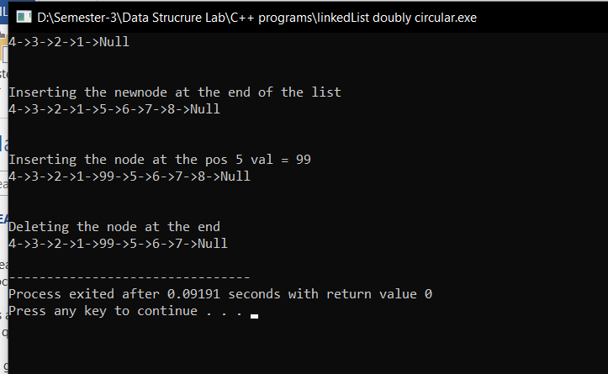

Task 3:
#include<iostream>
using namespace std;
class node{
public:
int data;
node* prev;
node* next;

node(int val){
this->data = val;
prev = NULL;
next= NULL;
}
};
class doublyLinkedList{
public:
node* head;
node* tail;

doublyLinkedList(){
head= NULL;
tail = NULL;
}
// Appending function
void append(int data)
{
node* newnode = new node(data);
if(head==NULL)
{
head=newnode;
head->next=NULL;
head->prev=NULL;
}
else
{
node *temp=head;
while(temp->next!=NULL)
{
temp=temp->next;
}
temp->next=newnode;
newnode->prev=temp;
tail=newnode;
}
}
//Inserting at the head
void insertAtHead(int val){
node* newnode = new node(val);
if(head==NULL){
head= newnode;
tail = newnode;
return;
}
newnode->next =head;
head->prev = newnode;
head = newnode;
return;}
// Display function
void display(){
node* temp = head;
while(temp!=NULL){
cout<<temp->data<<"<->";
temp = temp->next;
}
cout<<"NULL"<<endl;
}
// Concating fun
void concatenate(doublyLinkedList l,doublyLinkedList m)
{
node *temp=l.head;
while(temp!=NULL)
{
int d=temp->data;
this->append(d);
temp=temp->next;
}
temp=m.head;
while(temp!=NULL)
{
int d=temp->data;
this->append(d);
temp=temp->next;
}
}

};
int main(){
doublyLinkedList L;
L.insertAtHead(1);
L.insertAtHead(2);
L.insertAtHead(3);
L.insertAtHead(4);
L.display();
doublyLinkedList M;
M.insertAtHead(5);
M.insertAtHead(6);
M.insertAtHead(7);
M.insertAtHead(8);
M.display();
doublyLinkedList newlist;
newlist.concatenate(L,M);
newlist.display();
}
OUTPUT:
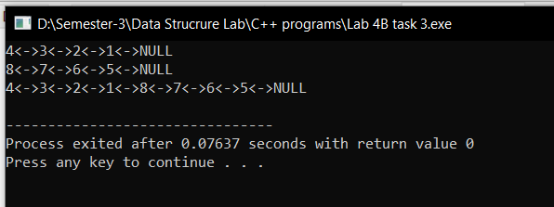

Task 3:
#include<iostream>
using namespace std;

class node{
public:
int data;
node* next;
node* prev;

node()
{
next=NULL;
}
node(int a)
{
data=a;
next=NULL;
prev=NULL;
}
};

class linkedlist{
public:
node* head;

linkedlist()
{
head=NULL;
}

void append(int data)
{
node* newnode = new node(data);

if(head==NULL)
{
head=newnode;
head->next=head;
}
else
{
node *temp=head;
do
{
temp=temp->next;
}while(temp->next!=head);
temp->next=newnode;
newnode->prev=temp;
newnode->next=head;
head->prev=newnode;
}
}
void swap(int a,int b)
{
node *temp=head;
int count=0;
while(count!=a-1)
{
count++;
temp=temp->next;
}
node *n1=temp;
temp=head;
count=0;
while(count!=b-1)
{
count++;
temp=temp->next;
}
node *n2=temp;

temp=n1->next;
n1->next=n2->next;
n2->next=temp;

temp=n1->prev;
n1->prev=n2->prev;
n2->prev=temp;

n1->next->prev=n1;
n2->next->prev=n2;
n1->prev->next=n1;
n2->prev->next=n2;
}

void display()
{
node *temp=head;
do
{
cout<<temp->data<<" ";
temp=temp->next;
}while(temp!=head);
}
};

main()
{
linkedlist list;
cout<<"Appending to list:\n";
list.append(1);
list.append(7);
list.append(4);
list.append(2);
list.append(6);
list.append(4);
list.append(5);
list.append(3);
list.append(9);
list.append(8);
list.display();

int a,b;
cout<<"\nEnter the Positions of list: ",cin>>a>>b;
list.swap(a,b);
list.display();
}
